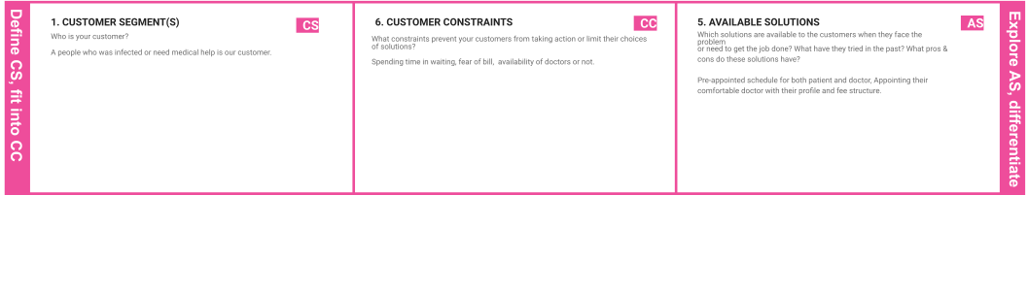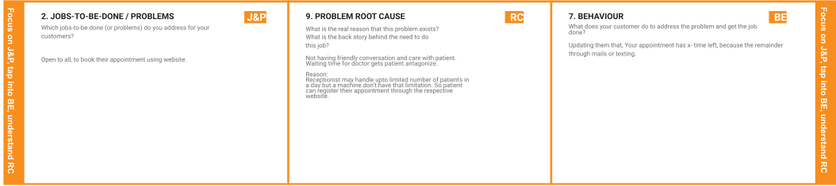

Project Title: Analytics For Hospitals' Health-Care Data Project Design Phase-I - Solution Fit Team ID: PNT2022TMID38936

|  |  |  |  |  |
| --- | --- | --- | --- | --- |
| **I D E N T I F Y**  **S T R O N G**  **T R**  **& E M** | **3. TRIGGERS**  **TR**  What triggers customers to act? | **10. YOUR SOLUTION**  **SL** | 1. **CHANNELS of BEHAVIOUR CH**    1. **ONLINE**   What kind of actions do customers take online? Extract online channels from #7 |  |
| Fear of ﬁtness. | A Patient needs a way to analyze and choose a Doctor by their proﬁle because of their experience | Instead of interacting with a doctor in physical mode, Patient can consult the doctor in online mode in an emergency situation. |
|  | and comfort. | **8.2 OFFLINE** |
|  |  | What kind of actions do customers take ofﬂine? Extract ofﬂine channels from #7 and use them for |
|  |
| **4. EMOTIONS: BEFORE / AFTER**  **EM**  How do customers feel when they face a problem or a job and afterwards? |  | customer development.  In Spite of consulting the doctor in online mode, a patient can interact with the doctor would be more adequate. |
| Before: |  |  |
| Patients feel hereafter they don’t need to continue, lose faith, Feel insecure.  After: |  |  |
| Patients were satisﬁed by selecting their desired doctor and got well by quality  treatment. |  |  |